Contents
Samuel Davies – Week 4 Individual logbook Discussion 2
Experience 2
Reflection 2
Action 2
Samuel Davies – Week 10 Individual Logbook Discussion 2
Experience 2
Reflection 3
Action 3
Appendix Xx – Week 4 Individual Logbook Evidence 3
Learning outcomes 3
General notes 4
Hours Breakdown 5
Logbook content notes 6
Team meetings 6
Client meetings 6
Advisor Meetings 6
Research 6
Documentation 6
Development 6
Testing 6
Appendix Xx – Week 10 Individual Logbook Evidence 7
Learning outcomes 7
General notes 7
Hours Breakdown 9
Logbook content notes 10
Team meetings 10
Client meetings 10
Advisor Meetings 10
Research 10
Documentation 10
Development 10
Testing 11

Samuel Davies – Week 4 Individual logbook Discussion
This discussion relates to the evidence present in appendix Xx – Samuel Davies Week 4 Individual Logbook Discussion.

Experience
During this week we had a lapse in work that we could be doing as around this time in the project we were still finding our footing in the project. Therefore, this week I took it upon myself to do a lot of research into AI concepts to make sure that I properly understood AI’s role in our project and would be able to contribute. This week I also noted that I had a lack of detail in my logbook’s that I had noticed due to comparing myself to the logbooks of my team members and from this point forward decided to bring more comprehensive logbooks due to the example that they had set.

Reflection
I did not get enough hours during this week; however, I believe this is partly due to the fact that the project had not realty kicked off yet and I felt there was not much to do, and I tried to fill that gap by doing as much research as I could without feeling as if I was researching things that were maybe not as useful to the project.

Action
At this point in time, I made a commitment that I wanted to be hitting 30 hours per week, which I understand to this point is the standard that we are supposed to be hitting per week regardless however given that around this time our AI PC was running I was more confident I would be able to hit this number. This week I also made the commitment to making sure my logs looked better.

Samuel Davies – Week 10 Individual Logbook Discussion
This discussion relates to the evidence present in appendix Xx – Samuel Davies Week 10 Individual Logbook Discussion.

Experience
This week was one of my best weeks as I managed to reach the 30-hour mark for hours completed, this was mainly due to the number of meetings we had this week as well as the work on the reports that I was able to complete this week, these reports were really great and enabled me to reach the goal of 30 hours for the week.

Reflection
I was happy with how much work I had completed during this week However, reflecting on the previous weeks, I have a lack of hours completed compared to my peers and is again as a result of not finding myself enough work to do, which is potentially motivated by there not being enough work to do however this is still a problem that I need to work on. Another challenge that I have had with since the week four logs is that I forgot to submit my weekly logs for two weeks, this was as a result of my tardiness and simply forgetting that I had not yet submitted the logs. I also mistakenly thought I could re-submit my logs by using my individual logbook correction point without discussing this action with my project manager which could negatively affect my team during the final panel, which was not my intention.

Action
As a result of me not getting enough hours in the previous weeks I made a considerable effort to get the required hours for week 10. Since attempting to re-submit my logs through the individual logbook correction point without discussing with either my advisor or my project manager we have since co-ordinated between ourselves for a solution to this problem and have remediated my tardiness so this will not happen again in future.

Appendix Xx – Week 4 Individual Logbook Evidence
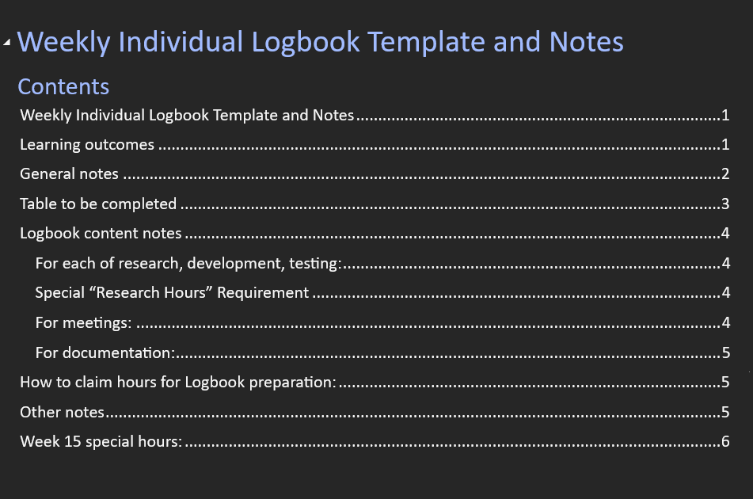

Learning outcomes
- Work collaboratively, using professional and interpersonal skills, cooperative methods and communication with team members, project sponsor and advisor.
- Apply the techniques and knowledge gained throughout the degree programme to research, analyse, design, develop, test and produce a solution
- Manage and control all aspects of the project

General notes
For our purposes, a week will start on Monday, and end on Sunday.

Each week you will upload an individual logbook.
Your logbook needs: A Cover page
A Table of Contents
A completed Table 1
Clear discussion of the work done in the week.

Do not include:
The list of Learning Outcomes
The notes in this document

Submitting incomplete logbooks, or logbooks with hours that cannot be verified, or not submitting a logbook for a week may impact your individual final grade for the Final Panel per “LO 4 Manage and control all aspects of the project”.

Also note, hours can be rejected if they are not accurate or clear.

It can also lead to an academic integrity investigation that can result in further penalties including failing the paper.

Hours Breakdown
You will need to include all hours worked per category and the running total of hours you have spent on Capstone to ensure you are on track to complete 450 hours.
Table 1 Hours to be completed
Category | Hours completed
Team meetings | 4h
Client meetings | 45m
Advisor meetings | 1h
Research | 12h35m
Development | 1h
Testing | 1h
Documentation | 4h
Logbook preparation | 1h
Sick leave/specific conditions
Other
Total Hours for this week | 24h20m
Running total of hours completed for  Capstone | 41h

Logbook content notes

Team meetings
Team meetings throughout the week plus a team meeting Friday morning before the project plan release.

Client meetings
For the client meetings we met with Geoff online to record our group video for the proposal.

Advisor Meetings
We met with Clement on Thursday to discuss the project proposal and make sure everything is up to speed before we submit everything.

Research
I Spent as much time as possible this week catching up on research that I missed out on in previous weeks in order to get up to speed with the concepts we are working on.

Documentation
Spent time documenting research as well as working on the project proposal.

Development

Testing
Spent looking at LM studio in my own time, trying to figure out how LM studio works.

Appendix Xx – Week 10 Individual Logbook Evidence
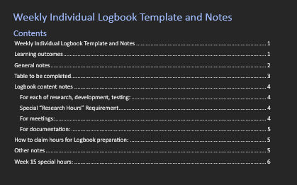

Learning outcomes
- Work collaboratively, using professional and interpersonal skills, cooperative methods and communication with team members, project sponsor and advisor.
- Apply the techniques and knowledge gained throughout the degree programme to research, analyse, design, develop, test and produce a solution
- Manage and control all aspects of the project

General notes
For our purposes, a week will start on Monday, and end on Sunday.

Each week you will upload an individual logbook.
Your logbook needs: A Cover page
A Table of Contents
A completed Table 1
Clear discussion of the work done in the week.

Do not include:
The list of Learning Outcomes
The notes in this document

Submitting incomplete logbooks, or logbooks with hours that cannot be verified, or not submitting a logbook for a week may impact your individual final grade for the Final Panel per “LO 4 Manage and control all aspects of the project”.

Also note, hours can be rejected if they are not accurate or clear.

It can also lead to an academic integrity investigation that can result in further penalties including failing the paper.

Hours Breakdown
You will need to include all hours worked per category and the running total of hours you have spent on Capstone to ensure you are on track to complete 450 hours.
Table 1 Hours to be completed
Category | Hours completed
Team meetings | 4h
Client meetings | 1h15m
Advisor meetings | 5h
Research
Development | 18h
Testing | 1h
Documentation
Logbook preparation | 1h
Sick leave/specific conditions
Other
Total Hours for this week | 30h15m
Running total of hours completed for  Capstone | 206h

Logbook content notes

Team meetings
Tuesday – Tuesday morning I showed up late to the team meeting because I had to clean up after my dog who decided my bedsheets and floor were a good place to throw up. However, during the meeting again, we prepared ourselves for the meeting, discussing who will present which slides and then we organised a test run before the meeting with Geoff. 10am – 2pm

Client meetings
Tuesday – client meeting with Geoff where we recorded the mid project presentation and then spent some time discussing with Geoff after the video was concluded. He had some interesting points to make about our project after the video concluded. 2.30 – 3:45

Advisor Meetings
Monday – advisor meeting with Bryce discussing the upcoming mid project update, he gave us some more pointers to fix in our presentation before we meet with Geoff. 8am – 10am
Monday – after our meeting with Bryce we had a meeting with clement as per the problem I had with my weekly logs and attempting to sort out a solution, we also talked about the mid project update presentation. 11 – 12pm
Friday – meeting with Bryce about starting work on the poster, final client deliverables, self-management review, version number updates, and the outcome of Dave and Sams missing logs. 9 – 11am

Research

Documentation

Development
Friday – Spent some time working on the format for my Nmap report as well as working on writing up the actual report. 5 – 9pm

Saturday – Spent some time working on my foremost report for the NINE.dd file. 12 – 6pm

Sunday – spent more time working on my foremost report, this time I went even further in the analysis using different tools to extract as much of the information inside the dd file as possible. However, this was deemed to be out of scope after a short discussion with the team. However, the time spent is not wasted, should we decided to use the extended analysis report in future. 12 – 6pm

Testing
Wednesday – scanned the SOIT network after gaining permission from Geoff. I scanned the network outside of school hours as per Geoff requirement. 11pm – 12am

